**[Supplementary Information]**

**Molecular Modeling of the Microstructure Evolution during Carbon Fiber Processing**

**Saaketh Desai, Chunyu Li, Tongtong Shen, Alejandro Strachan[1]**

**Purdue University, West Lafayette, IN, USA 47906**

## Using the MD-CF code

The code to simulate the crosslinking procedure is available at <https://github.rcac.purdue.edu/StrachanGroup>. The README file associated with the GitHub repository provides instructions to download and use MD-CF.

## Simulating a Powder X-Ray Diffraction (XRD) Pattern

We use the LAMMPS software package to simulate the XRD pattern. The procedure used is detailed in Coleman et al. [1], where the simulation cell is divided into a grid in reciprocal space, the grid spacing determined either manually or using the cell lengths. At each point of this grid, the structure factor is evaluated, using the following equation

$$F\left(k\right)=\sum_{j=1}^{N}{ \left(f_{j}\left(θ\right) \exp{(2πi k• }r_{j})\right)}$$

where fj(θ) denotes the atomic form factors and **rj**­ denotes the atomic coordinates. The structure factor, which gives the scattering due to the atom positions in all the unit cells, can then be used to calculate peak intensity, using the following equation,

$$I=LP(θ)\frac{{|F|}^{2}}{N}$$

where LP (θ) denotes the polarization factor, used to account for unpolarized beams as well as finite crystal sizes.

## Evaluating the transverse stiffness of MD-CF microstructures

Typical stress strain curves for MD-CF microstructures are shown in Fig S1 and the Young’s modulus for each of these curves is estimated by performing a linear fit to the data. Given the complex nature of the microstructure and the system size, we see fluctuations in the stress built in the material as strain is applied. These fluctuations result in deviations from an ideal linear fit and these deviations are represented as error bars in the Young’s modulus.

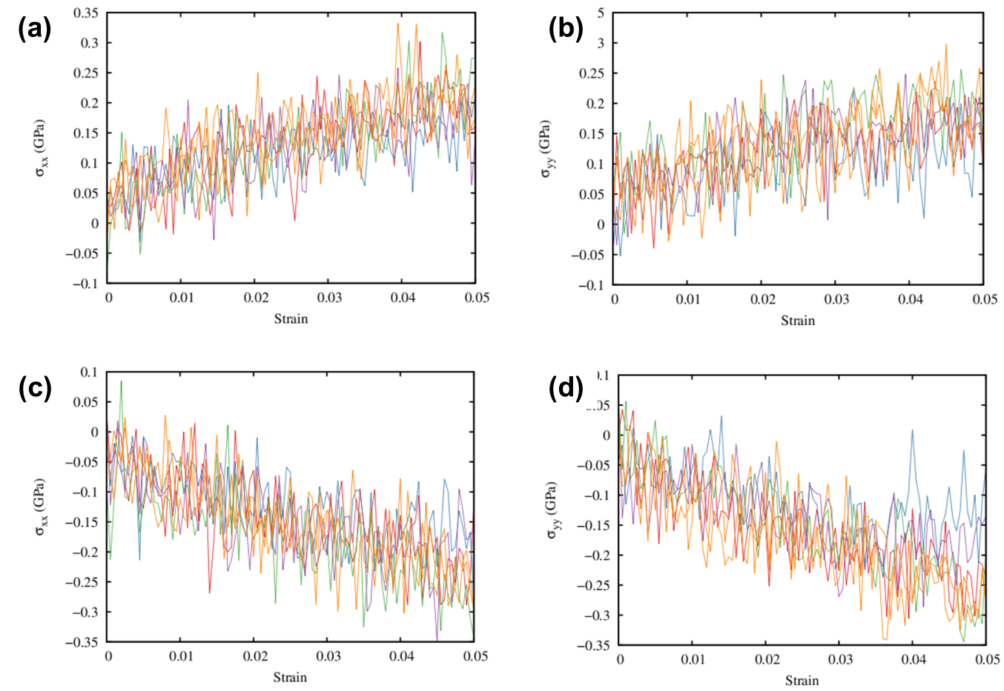

*Figure S1: Stress strain curves (in tension) for same representative MD-CF microstructures in the (a) X direction and (b) Y direction. (c) and (d) Stress strain curves in compression. The parameters used for these set of microstructures were*: *R0=5Å, R1=2.85Å, θ0=60° and =0.1*

## Importance of the distance and angle based cutoffs in the MD-CF scheme

Figure S2 shows the strain energy change as bonds are created between chains that are poorly oriented, in addition to change in energy required to form bonds according to the two-cutoff model. The potential energy, the torsional energy (4-body term) and the angle energy (3-body term) are computed relative to the case where the chains are perfectly aligned (0°).

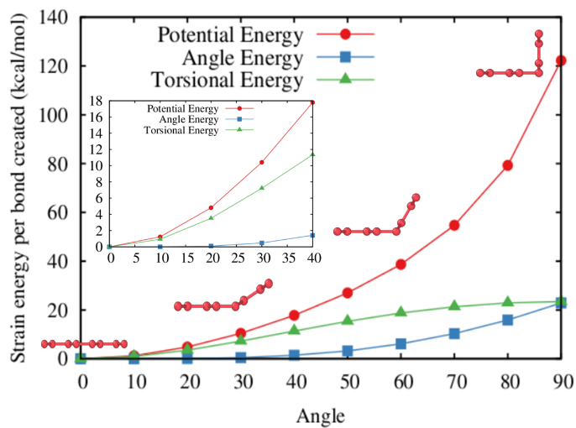

*Figure S2: Change in energy as a function of misalignment between two representative ladder structures. The increase in energy with misalignment shows the need to penalize bond formation between poorly oriented ladder structures.*

Similarly, to evaluate the role of a two-cutoff model, we compute the strain energy change as bonds are created between two ladder structures. For this, we begin with a simulation cell that consists of a set of randomly packed ladder structures and replicate the structure along the out-of-plane direction such that the chains are seven monomers long. We choose two chains at random and a single bond is created at the center of the two chains (see Figure 3(c) in the manuscript). We perform an energy minimization on this structure (tolerance of 10-10) and compare the energy relative to the energy of the initial (unbonded) state. We then create two bonds between the same set of chains, one above and one below the previous bond, perform another minimization and compare the energy to the previous structure (with a single bond). As we create further bonds, we compare the change in energy (per bond created) between the current and the previous structure. This simulation describes the decrease in strain energy associated with each successive bond, justifying a two-cutoff model as described in the manuscript.

## Effect of simulation cell dimension on evaluated transverse modulus

We evaluate the transverse modulus for three different cell dimensions (2.5 nm, 5.15 nm and 7.20 nm) to ensure that there are no size effects in the reported moduli. We find no statistical difference between the moduli (in the X, Y directions as well as the average) for the evaluated cell dimensions (see Fig S3).

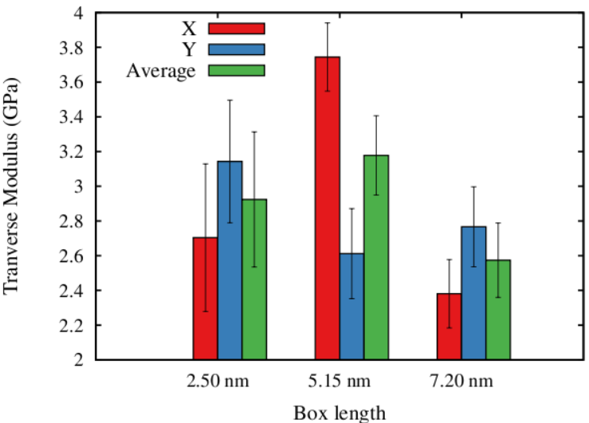

*Figure S3: Transverse moduli in the X and Y directions (and the average of the two) evaluated for different box lengths (in the Z direction)*

## References

1S.P Coleman, D.E Spearot, L. Capolungo, Model. Simul. Mater. Sci. Eng. **21**, 1 (2013)

1. Corresponding author: E-mail: [strachan@purdue.edu](mailto:strachan@purdue.edu)